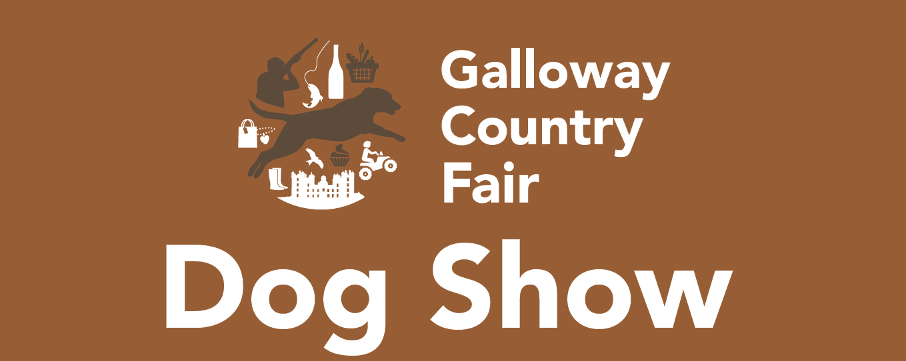

SATURDAY 17TH AUGUST 2019
REGISTRATION

DOGS DETAILS
Dogs Name: ………………………………………………………..
Breed:………………………………………….………………….…
Age:……………………………………………………………….…

OWNERS DETAILS
Owners Name:…………………………………….….…..
Contact Email: …………………………………………....

We would like to enter the following categories

- Gundogs
- Any other breed
- Best trick

Please note there will be a photographer at the event. If you do not want to be photographed please make a member of staff aware.

- I would like to sign up to emails about Drumlanrig Castle. Email addresses will not be used for any other purpose. For full details please see the privacy statement on www.gallowaycountryfair.co.uk/privacy-policy/

Signed:…………………………………………….................

Please email to fgrant@buccleuch.com

